Triple BC Productions

By: Bryan Clark

Montgomery County Community College

14Dec17

Executive Summary:

This web site is designed to display and convey multiple skills obtained and in use consistently by the developer. Key pages highlight various skills either subtly or very noticeably and sleek enough catch the users’ attention. Pages include slideshows, descriptions of marketing skills, information about the owner, and contact input for the users.

Wire Frames: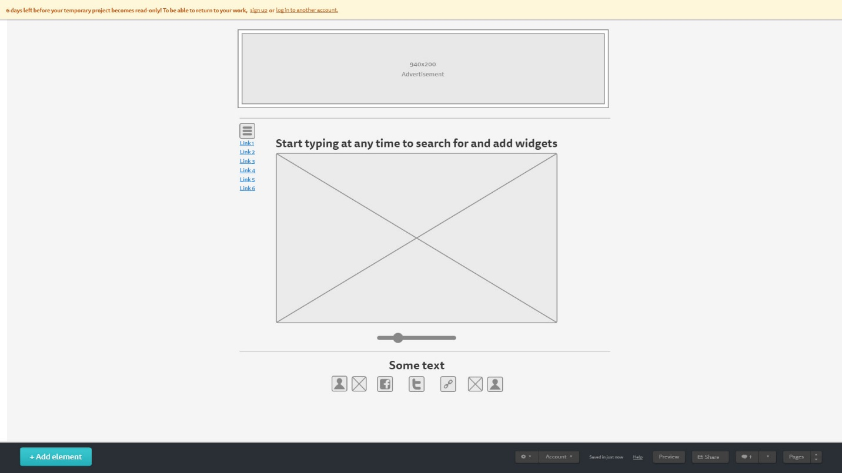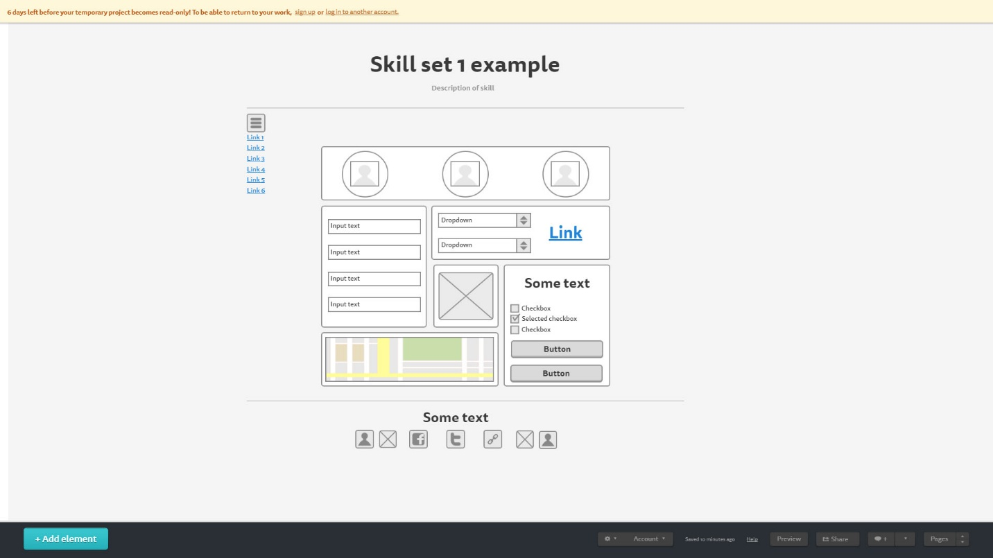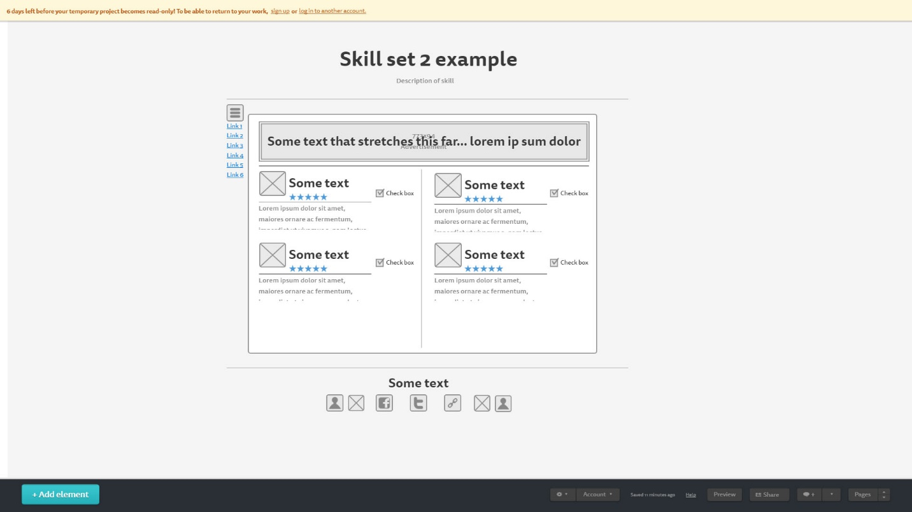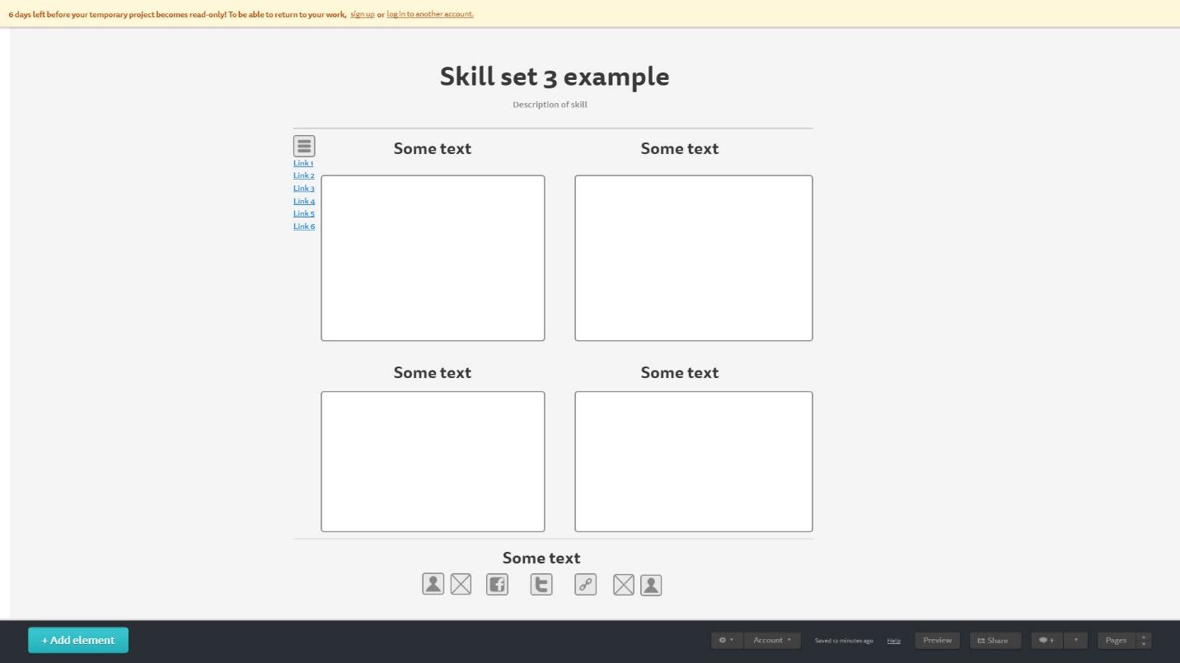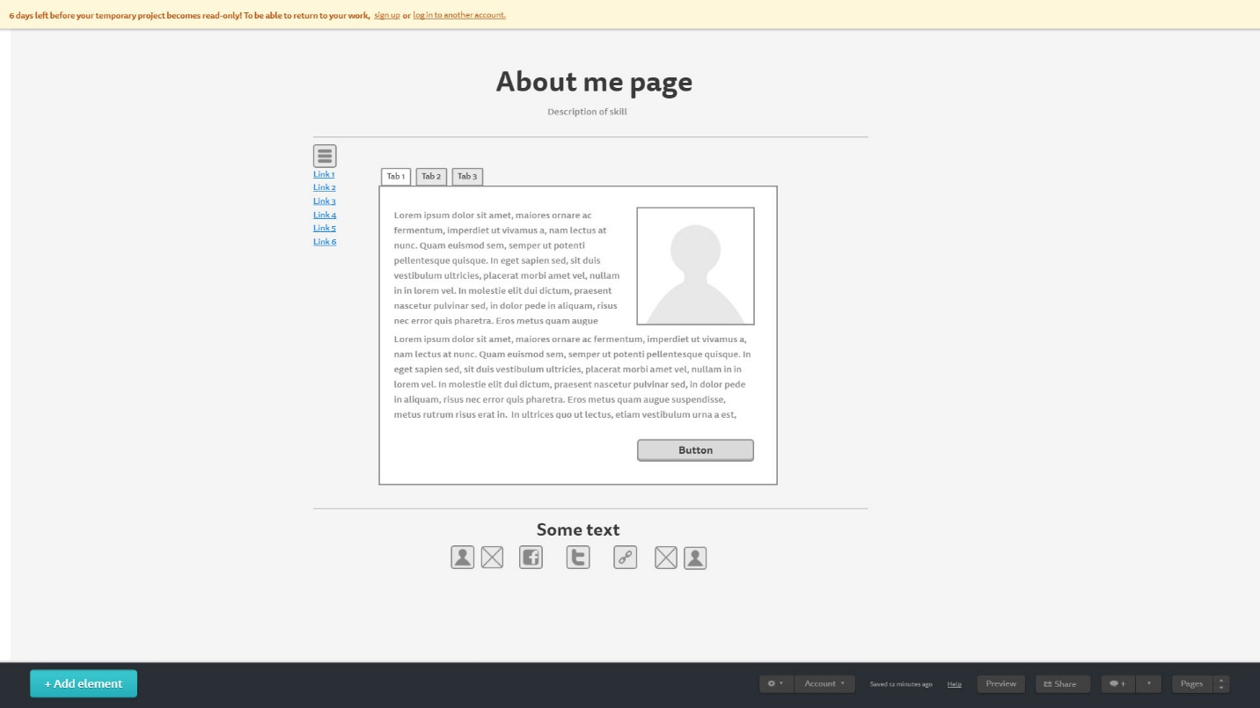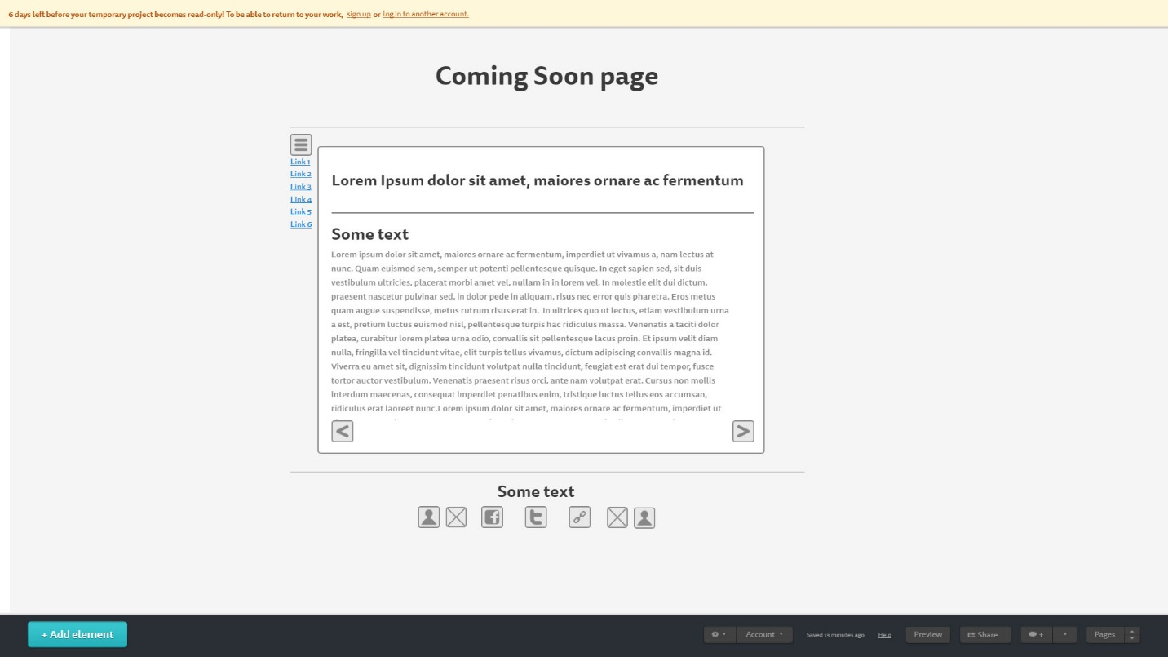

Style Guide:

/\* Body Style \*/

body {

height: 100%; /\* Maintain body height integrity. \*/

background: whitesmoke; /\* Add white background to center content. \*/

border: 5px solid black; /\* Border around center content. \*/

vertical-align: middle; /\* Center all content. \*/

}

html {

background: steelblue;

height: 100%; /\* Maintain page height integrity. \*/

display: table; /\* Make webpage center in table format. \*/

margin: auto; /\* Keep everything centered. \*/

}

/\* Squeeze content together enough for white space to show on either side. \*/

.theNeverEndingBody {

width: 95%;

margin: auto; /\* Maintain center integrity. \*/

}

/\* Navigation menu follows user scroll. \*/

.nav2 {

position: fixed;

margin-left: -200px; /\* Pull Nav bar icon out of body and html content. \*/

}

/\* Logo parameters. \*/

#logo1 {

position: relative;

margin: auto;

height: 400px; /\* Optimal image size. \*/

width: 100%; /\* Optimal image size. \*/

}

/\* Nav icon parameters. \*/

#logo2 {

position: absolute;

height: 150px; /\* Optimal image size. \*/

width: 150px; /\* Optimal image size. \*/

border: 1px solid black;

border-bottom: 1px solid black;

border-left: 1px solid black;

border-top: 1px solid black;

border-right: 1px solid black;

border-radius: 30px 30px 30px 30px;

}

/\* Nav hover effects. \*/

#logo2:hover {

color: black;

border: 10px solid black;

box-shadow: 11px 11px black;

opacity: .7;

}

/\* Full screen overlay for navigation bar.\*/

.overlay {

position: fixed;

bottom: 0;

right: 0;

width: 100%;

height: 0%;

background: black;

overflow-x: hidden;

z-index: 5;

transition: all 0.5s;

}

/\* Center align and make links clickable from all side horizontally. \*/

.overlayContent {

position: relative;

top: 25%;

width: 100%;

text-align: center;

margin-top: 30px;

}

/\* Overlay font decoration. \*/

.overlay a{

padding: 10px;

color: white;

font-size: 30px;

text-decoration: none;

display: block;

}

/\* Overlay hover color. \*/

.overlay a:hover{

color: blue;

}

/\* Overlay Close button. Top right. \*/

.overlay .closeButton{

position: absolute;

top: 20px;

right: 50px;

font-size: 40px;

}

/\* Grid main settings. \*/

.wrapper {

display: grid;

grid-template-rows: 3, 1fr;

grid-template-columns: 4, 1fr;

text-align: center;

align-content: center;

grid-gap: 20px;

min-width: 100%;

}

/\* Container 1. \*/

#container1 {

background-image: url(/Images/me.jpg), url(/Images/me.jpg), url(/Images/me.jpg);

background-repeat: no-repeat, no-repeat, no-repeat;

background-position: 100px top, 500px top, 900px top;

background-size: 200px, 200px, 200px;

background-blend-mode: color-burn;

height: 200px;

color: aqua;

background-color: tan;

grid-column: span 3;

grid-row: 1 ;

border: 5px solid black;

border-bottom: 5px solid black;

border-left: 5px solid black;

border-top: 5px solid black;

border-right: 5px solid black;

border-radius: 10px 10px 10px 10px;

}

/\* Container 2. \*/

#container2 {

color: teal;

background-color: tan;

grid-column: 1;

grid-row: 2 / span 2;

border: 5px solid black;

border-bottom: 5px solid black;

border-left: 5px solid black;

border-top: 5px solid black;

border-right: 5px solid black;

border-radius: 10px 10px 10px 10px;

}

/\* Vertical split. \*/

.splitRow {

font-size: 2em;

flex-flow: column wrap;

float: left;

margin-left: 50px;

}

/\* Reposition drop down menu. \*/

#lister{

float: left;

margin-left: 100px;

}

/\* Reposition Link. \*/

.linker {

float: right;

margin-right: 30px;

font-size: 2em;

}

/\* Form Rows. \*/

.formRow {

font-size: 2em;

display: flex;

margin: 2px 0px;

flex-flow: row wrap;

}

/\* Apply to all rows. \*/

.formRow > \* {

flex: 1 1 30px;

}

/\* Text area box dimensions. \*/

#comments {

display: block;

height: 100%;

width: 80%;

}

/\* Container for text area box. \*/

.blockRow {

position: relative;

align-items: center;

height: 150px;

}

/\* Container 3. \*/

#container3 {

color: azure;

background-color: tan;

grid-row: 2;

grid-column: span 2;

border: 5px solid black;

border-bottom: 5px solid black;

border-left: 5px solid black;

border-top: 5px solid black;

border-right: 5px solid black;

border-radius: 10px 10px 10px 10px;

}

/\* Container 4. \*/

#container4 {

background-image: url(/Images/TBC2.jpg);

background-position: center;

background-repeat: no-repeat;

background-size: cover;

opacity: .5;

color: aqua;

background-color: tan;

grid-row: 3;

grid-column: 2;

border: 5px solid black;

border-bottom: 5px solid black;

border-left: 5px solid black;

border-top: 5px solid black;

border-right: 5px solid black;

border-radius: 10px 10px 10px 10px;

}

/\* Container hover features. \*/

#container4:hover{

opacity: 1;

transform: rotate(359deg);

}

/\* Container 5. \*/

#container5 {

color: teal;

background-color: tan;

grid-row: 4;

grid-column: span 2;

border: 5px solid black;

border-bottom: 5px solid black;

border-left: 5px solid black;

border-top: 5px solid black;

border-right: 5px solid black;

border-radius: 10px 10px 10px 10px;

}

/\* Map dimensions. \*/

#map {

height: 200px;

width: 400px;

margin: auto;

}

/\* Container 6. \*/

#container6 {

color: azure;

background-color: tan;

grid-row: 3 / span 4;

grid-column: 3;

border: 5px solid black;

border-bottom: 5px solid black;

border-left: 5px solid black;

border-top: 5px solid black;

border-right: 5px solid black;

border-radius: 10px 10px 10px 10px;

}

/\* Check box settings. \*/

.checkbox {

height: 50px;

margin-right: -10px;

background-color: blue;

}

/\* Check box checked features.\*/

.checkbox:checked {

transition: 5s;

background-color: aqua;

opacity: .5; /\* Fade away selection. \*/

}

/\* Button settings. \*/

.button1 {

max-width: 50%;

color: whitesmoke;

background-color: green;

border-radius: 10px;

border: none;

margin: auto;

box-shadow: 5px 5px 5px 5px green;

transition: .5s;

}

.button1:hover{

background-color: blue;

border-radius: 60px;

border: 1px solid;

box-shadow: 5px 5px 5px 5px blue;

height: 50px;

transform: rotate(10deg); /\* Rotate button. \*/

}

.button2 {

max-width: 50%;

color: whitesmoke;

background-color: red;

border-radius: 10px;

border: none;

margin: auto;

box-shadow: 5px 5px 5px 5px red;

transition: .5s;

}

.button2:hover{

background-color: blue;

border-radius: 60px;

border: 1px solid;

box-shadow: 5px 5px 5px 5px blue;

height: 50px;

transform: rotate(-10deg); /\* Rotate button. \*/

}

/\* Grid Paragraphs. \*/

.shortP {

margin: auto;

width: 200px;

}

#shortP1 {

width: 100%;

margin: auto;

font-size: 1.5em;

}

Project Management:

Time estimate 1 day per page. 6 hours per session. 6 total long sessions excluding class time and general troubleshooting.

Problems solved: Automatic and manual Slide shows.

Research time used for project: approximately 4-6 hours.

Designing TBC Logo: 2 Hours, including research and tutorials.